`
Vulcan Activity Tracker
Weekly Report

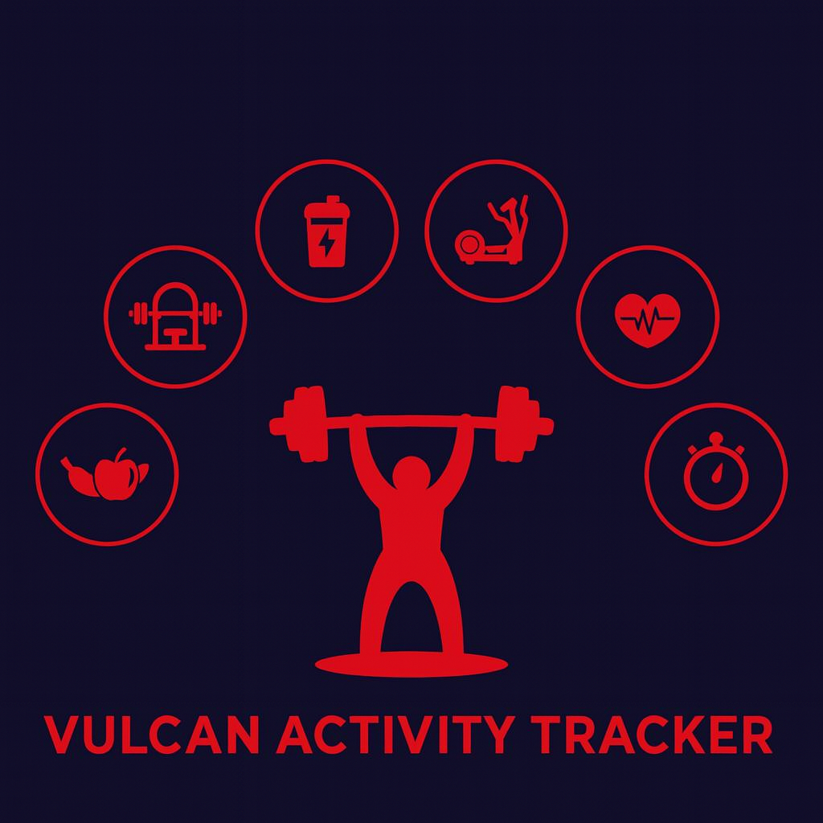

Week 8
Team Members:
Margo Bonal
John Gerega
Luke Ruffing

Professor: Dr. Weifeng Chen

Course: CMSC-4920-Senior Project II
School: Pennsylvania Western University

Table of Contents

Project: Vulcan Activity Tracker 2
Goals Accomplished: 2
Challenges Faced: 4
Solutions: 4
Team Progress: 5
Gantt Chart: 7
Week 8 Plan: 7
Member Contribution: 8
References 8

Project: Vulcan Activity Tracker
To complete the proposed goals in previous week’s report, our team followed a strict schedule of daily progress and communication. Our team had 4 main goals to complete, which included implementing a feature that allows users to receive an email to verify their account or recover their password, adding a user profile section that allows a user to delete their account or update their username, and continuing development of both the challenges and teams page. Additional goals included continued development of the maps page. Since each goal needed time allocation for development and testing, we assigned each goal priority based on how they were connected to each other. Throughout the discussion, we decided that not allowing access to the tracker before a user is properly logged in was the main goal of this week. Achieving this goal will help keep the privacy of our tracker.

Goals Accomplished:
The first goal accomplished was implementing a user profile section that allows users to delete their accounts and update their usernames. This section simply shows two buttons at the moment, which are buttons to delete the account and change the username. The next steps are to format the page to be more user-friendly, but getting those two functions to work correctly helped us take a huge step forward
The second goal accomplished was enhanced features on the map page. The maps page now includes a weather section that shows the user the current weather around campus.
The third goal was to get emails to send out, but we ran into a stumbling block when trying to do this

Challenges Faced:
(Number aligns with its solution below)
- Resend Application policies – we had successfully gotten our code to the point where we could send the email to the users to recover their password. However, the error we were getting was that we needed to verify the pennwest.edu domain with DNS records that we do not have access to. So, we had to go looking for a new application to use, which put us back to step 1 in this journey to send emails.
- User Profile Functions – Both functions caused problems when trying to implement them. First, there was the delete account feature, which would not work until we cleared all foreign key references before deleting the user from our user table. The username change was causing an issue where, when the username was changed, their data would no longer be available to view.
- Solutions:
1. We found a new application called Dashboard. This application gives us 100 free emails per day in the trial plan, which does not require us to verify our domain. This could cause issues in the future if we have a large number of users, but for testing purposes, it is very helpful. We are now working to fit the dashboard API into our code in order to send an email with that key instead of the Resend key we attempted to use before hand.
2. The User Delete function was an easy fix. We had to make sure we deleted the UserID column in each table that it was referenced. Once we did that, we could delete the UserID in the User table with no issue. Now the user can delete their account and they will be returned to the main page of the application, With the username function, we were not updating the current user logged in correctly, so the application was still working on the assumption of their old username, so we had to update the current username to the newly updated username. Once we did this, we had no issues and the user’s data was successfully transferred to be associated with their new username.

Team Progress:
Throughout week 8 our team has made substantial progress to the Vulcan Activity Tracker. According to our Gantt chart our team is still on schedule for many parts of the project. One of the primary goals accomplished this week was implementing a required logged in feature that prevents users from bypassing user authentication by manually type in URLs like “/dashboard”. This feature itself greatly improves the security and integrity of our project.
Another major step forward was conducting user testing. We had multiple users create accounts and go through the activity trackers various features including activity tracking, leaderboard, clubs and challenges. The feedback from the test group was documented and compiled in a user feedback file that our whole team has access to. We believe although we are still months away from our tracker being a finished product, user testing is an extremely important and valuable process. This is because getting users without biases or technical knowledge to run through a program exposes issues the developers might not have previously considered. For example, one test user suggested a feature that has the users confirm the password they chose while making an account, a simple feature used is many applications to ensure the user didn’t accidentally mess up their wanted password, but for us developers who just want to log on to the application as fast as we can to test other features, we never thought of it.
Additionally, after much research our team found a service email provider that can be used to implement a password recovery feature. After evaluating many options for an email provider, our team landed on Resend as the best application for our needs. We determined this because Resend allows us up to 100 emails per day, and 3,000 emails per month, for free, which for our estimated user base will work perfectly.
The last accomplishment of this week was the continued development of both our challenges and teams pages. The development of both is moving at a slow but steady pace as we are trying to link the activity data and the frontend to present users with a dynamic UI that gives them their data in ways that improve clarity and organization.

Gantt Chart:
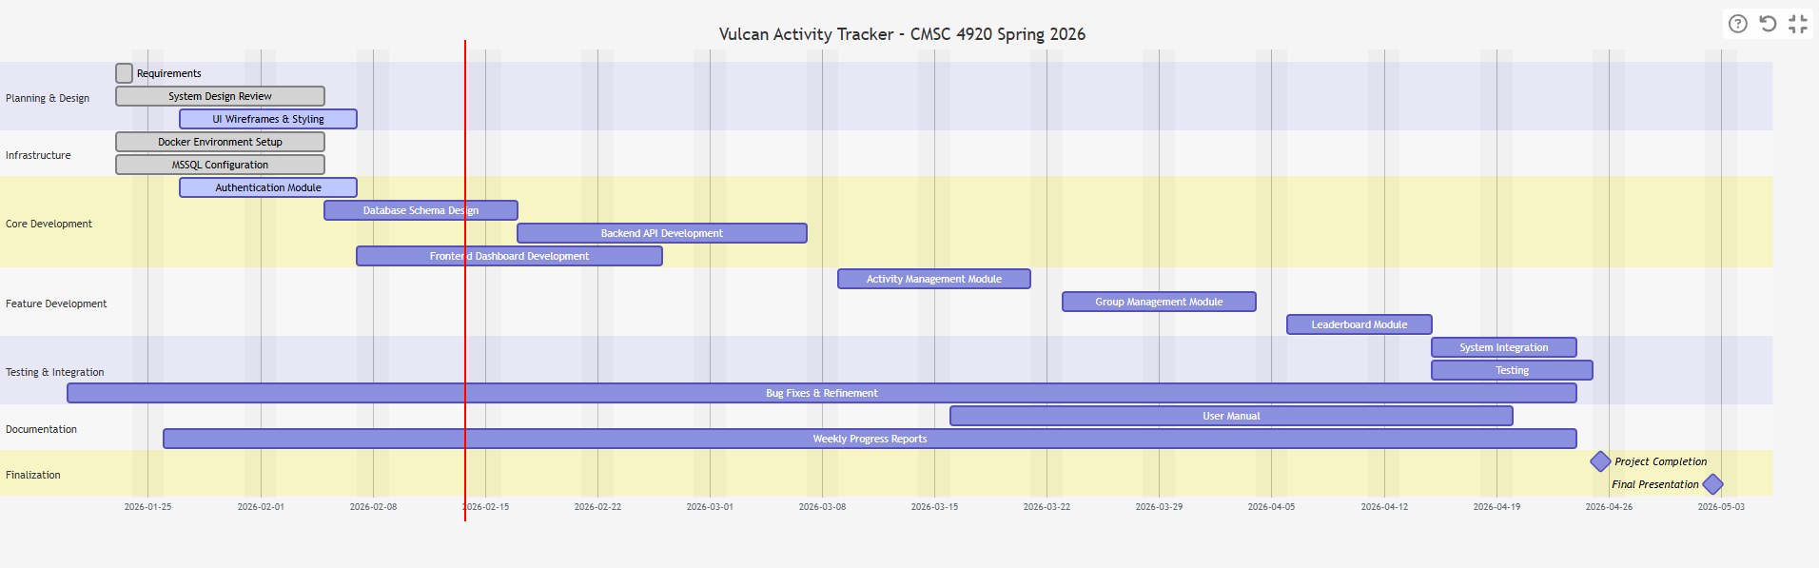

Week 8 Plan:
Our week 9 plan is going to focus on getting these recovery emails up and working. We also want to consider our user feedback and begin making those changes, with some of them already being completed. One of those features is the User Profile Section, which would also allow us a chance to implement a delete account feature that was also requested by the user. We also want to continue to improve the pages that are developed, with some of them still having minor bugs in them. We also want to add additional features to the Maps page, such as delete route.

Member Contribution:

Team Members
Margo Bonal: | - Team meetings, Week 7 Report & Slides, Maps page, User Authentication, Maps Page, Database/API logic, research
John Gerega: | - Team meetings, Week 7 Report & Slides, Teams page, Password recovery, research
Luke Ruffing: | - Team meeting, Week 7 Report & Slides, Challenges page

References

Agafonkin, V. (2025, Aug 16th). Leaflet.
https://leafletjs.com/
OpenStreetMap. (2025). OpenStreetMap.
https://www.openstreetmap.org/copyright

